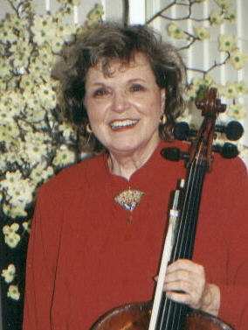

Dorothy Amarandos is a graduate of the Eastman School of Music, a student of Luigi Silva, with Bachelor’s/Master’s degrees and Performer’s Certificate. She played in the Rochester Philharmonic under Erich Leinsdorf for many years while teaching privately, and was lecturer at the University of Rochester. Also in Rochester, as Founder/ Director/Producer of Ars Antiqua (a national touring group of actors, dancers, singers, and players of original instruments), Dorothy created and performed her 22 original concert-productions based on material from the Medieval, Renaissance, and Baroque. Later in Columbus, Ohio, she was professor of cello at Ohio State University as well as Denison University, Ohio Wesleyan University, and Otterbein College, and was principal cellist of the Columbus Symphony. Currently she teaches a large class of private cello students of all ages in her studio in Reston, VA.

