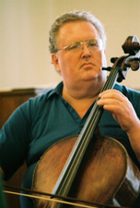
Gary Fitzgerald has had a wide-ranging career in Montreal, New York City, Washington DC, and Perth (Western Australia) as a cellist, pianist, conductor, arranger, clinician. He was trained at the Juilliard School where his teachers included Leonard Rose, hanning Robbins, and Lynn Harrell. He was Assistant Principal Cellist with the Montreal Symphony Orchestra and Principal Cellist for the Australian Broadcasting Corporation in Perth, and a member of several prestigious orchestras and chamber ensembles in the U.S. He left New York to become a full-time church musician, holding directorships in Virginia and in South Carolina. Currently, as Director of Worship Arts for the Church of the Apostles in Fairfax, VA, he is responsible for a full program of offerings in music, drama, dance, and the visual arts.

